
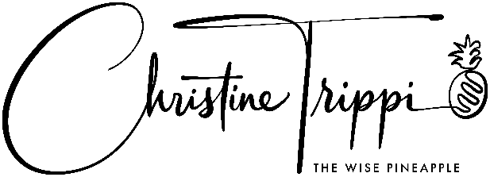

THE WISE PINEAPPLE

Christine Trippi is the author of Yes Is the Answer, the #1 bestselling book for hospitality on Amazon, keynote speaker, hotel consultant, and Founder & Chief Executive Officer at The Wise Pineapple. This private hospitality brand connects ambitious leaders to their goals. Christine helps hotel teams to Be Confident, Empowered, and Lead from the Heart through mindset and proprietary strategy that leverages each leader to take action and get Sweet Results!

Before stages and Platinum Elite status with United Airlines, Christine began her 36-year career as a laundry attendant/van driver at the Hampton Inn. Since she was 17 years old, her mission has been to change the world one YES at a time!

Over her career, Christine has served a vast array of select, full, and resort hotels. Her last ten years were with Marriott International as General Manager, where Marriott recognized her as the Diamond General Manager and General Manager of the Year for Courtyard. In 2015, Christine moved to Marriott’s Continental Lodging Services, in an above property roll supporting the Americas, Select Service hotels for profit, brand standards, and associate and guest service scores. (465+hotels)

Christine is a life-long learner and has enough energy to power the state of Texas! She likes her nails pink, her Diet Coke with Captain, and she is obsessed with getting YOU Sweet Results!

Christine’s professional accomplishments have gained her recognition from the International Hospitality Institute, and she was honored with the following:

- 100 Most Powerful People in Hospitality
- 25 Most Influential Women in Hospitality
- 25 Most Inspirational Executives in Travel & Hospitality
- 10 15 Trainers in Hospitality

The Global Guru named Christine’s Yes Is the Answer the #2 Best Training Program for 2021 – 2023, and she appeared on Shep Hyken’s, Be Amazing or Go Home, Amazon Prime T.V. show.

Christine is a life-long learner and has enough energy to power the state of Texas! She likes her nails pink, her Diet Coke with Captain, and she is obsessed with getting YOU Sweet Results!

Bring your energy and high fives because she also has prizes! Whoop-Whoop!

